FEBRUARY 2020
NEWSLETTER
DON'T FORGET!!! NO MEDITATION ON TUE, FEB. 25.
MARDI GRAS DAY!
We'll resume on Tuesday, March 3.
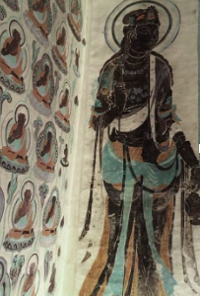
THE EIGHTFOLD PATH: The Fourth Noble Truth

The Buddha provided assistance for those who study his teachings. The Buddha taught that there are means to achieve the end of suffering. In the fourth noble truth Magga: The Noble Truth of the PATH we learn that insight occurs when we change our thinking and behavior. The Eightfold Path is this guide for living without clinging to desire.

- Wise Understanding- understand The Four Noble Truths. Understand your own thoughts and perceptions.
- Wise Thought- Think kindly of others and avoid dwelling on the past or future. Be in the present moment.
- Wise Speech- Speak kindly and truthfully
- Wise Action- Act kindly toward all living (sentient) beings. Do not be attached to the results of your actions.
- Wise Work- Do work that does not harm others
- Wise Effort- Be diligent in clearing your mind of thoughts that keep you in the endless cycle of suffering.
- Wise Mindfulness- Be fully aware of what you are doing; always have concern for others.
- Wise Concentration- Concentrate during meditation to achieve a state of “oneness” with any situation.

Each of these is worth its own Dharma session, and discussion may add to our understanding and insight about how they each resonate in our daily lives.
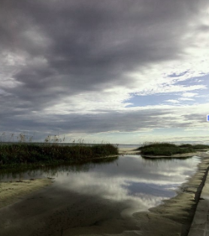
Since having moved into our new space, we've discovered we need some things to make it feel a bit more like home. Below is a list of items which will help us provide a comfortable experience for practitioners and visitors every time we meet for a sit, meal, or retreat. Kindly ship them to MIM, 13367 Chris Dr, Gulfport, MS 39503, USA.
Thank you for your generosity and support.
​
Kitchen and Bathroom​
1 spaghetti pot
​
Meditation Space
6 folding chairs
3 large cushions (Zabuton)
2 small round cushions (Zafu)
​
Outdoor Spaces
1 solar flood light
16 solar path lights
1 large Buddha statue
​
Indoor Spaces
1 large Buddha statue
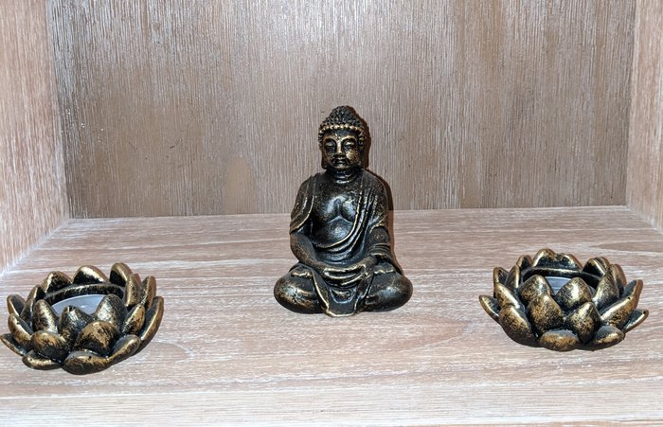
DAYLONG RETREAT
for Beginners

Join us Saturday Feb. 29, 9:30 am to 4:30 pm, for this silent Beginners Daylong retreat. Includes Dharma talks, walking and sitting meditations and a light lunch. As with all of our programs here at MIM, this event is free although donations to the organization are always appreciated.
RSVP
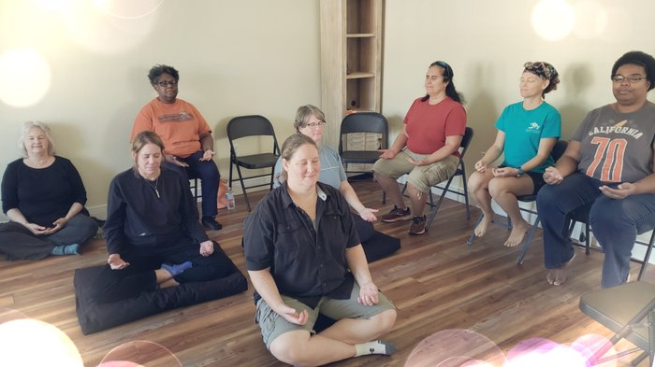
NEW CLASS:
LEARN HOW TO MEDITATE

Sundays at 10am starting on March 1st

Join us for this five week class and learn how to meditate on: the breath, the body, emotions, thinking and attitude.

Come for one class or all five. Each session is a stand-alone lesson, but recommended as a series.
RSVP
1/2 DAY Clean up & Meditation (weather permitting)

Sat, Mar 07, 9:30 AM – 12:30 PM
13367 Chris Dr, 13367 Chris Dr, Gulfport, MS 3950

Schedule:
Meditation 9-9:30
Dharma talk 9:30-9:45
Clean up 10-12
Lunch 12-12:30

Please Bring WORK GLOVES and wear socks as we will be working outdoors.
Join Us
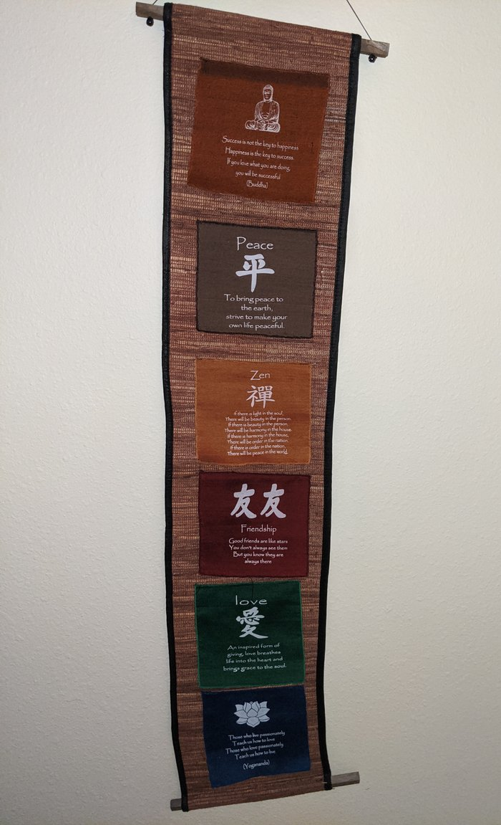
Tuesday Evening Dharma talk and Meditation

Every Tuesday at 6pm
(NO CLASS ON TUE, FEB 25)

13367 Chris Drive Gulfport
RSVP
WE ARE LOOKING FOR:

A Gardener........
Do you like gardening. We are looking for someone to plan, establish, and manage a small garden at our Center.

A Social Media Manager.......
Do you enjoy using FB and Instagram? We are looking for someone to maintain our social media accounts by continually updating them with photos and information about past and future events.

Testimonials......
Have you benefited from the Dharma talks or meditation in general? Can we share your photo/experience on Facebook? Please contact Lanee (our Sangha Director).
Contact Lanee

