Mississippi Insight Meditation
September 2019 Newsletter
Welcome to Mississippi Insight Meditation or MIM! We have begun a new endeavor to offer Vipassana (insight) meditation to Mississippi. We invite you to bring your beginner’s mind to the classes and programs we present. Whether you join us at our six class program on insight meditation (each one hour) or a one-time overview, or we can come to you in your office or as a program at your organization’s meeting.

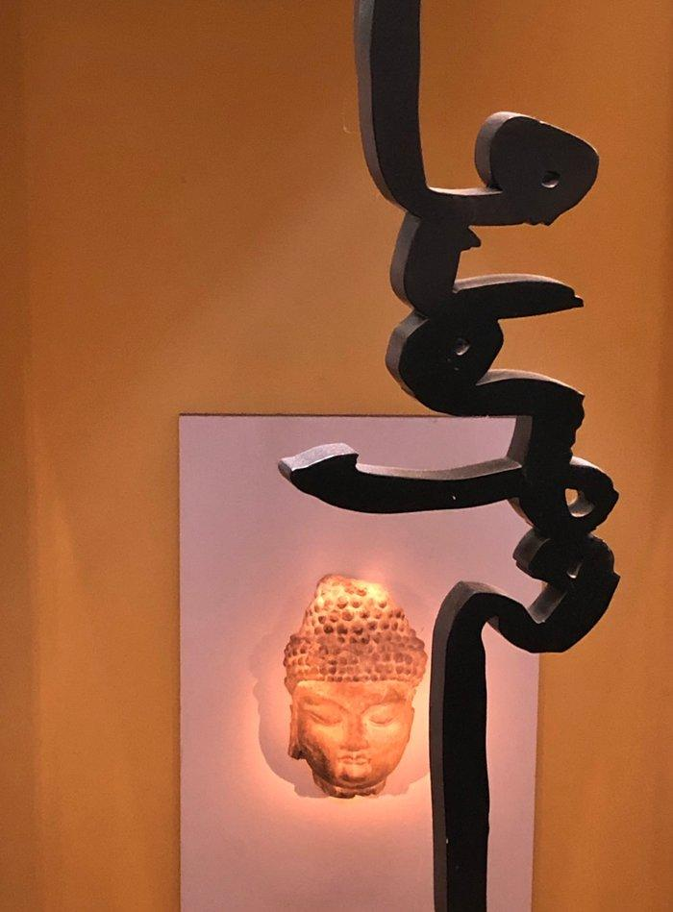
Whether part of a spiritual practice or not, insight meditation is available to each of us whenever we can sit safely (not recommended when operating machinery) and quiet our minds. While retreats and fantastic scenery are not to be turned down when available, we are where we need to be in the here and now. Really, that is quite powerful! Having others to share the space while we meditate is comforting to some, but not required. However some instruction is recommended, especially if one is considering a lifelong practice. We are pleased to announce that there is help available when looking for assistance in how to meditate.

